P1

📘 SPRINT 1 TECHNICAL SPECIFICATION
Multimodal Facial Behavior Prototype (Personal Deviation Modeling)

1. SYSTEM PURPOSE

1.1 Primary Objective
Demonstrate that literature-defined behavioral facial features can be:
- Operationalized into mathematical form
- Computed using MediaPipe FaceMesh (478 landmarks)
- Geometry-normalized
- Centered relative to a Personal Session Baseline (PSB)
- Expressed as bounded deviation (0–1)
- Stored without retaining biometric identity data

1.2 Scope of Sprint 1
- Personal deviation modeling only
- No diagnosis
- No population calibration
- No cross-session scaling
- No identity storage
- This system measures within-session deviation from personal neutral baseline.

2. CORE MODEL CONFIGURATION

2.1 Face Model
- MediaPipe FaceMesh
- 478 landmarks (468 face + 10 iris)

2.2 Coordinate System
- Normalized image coordinates
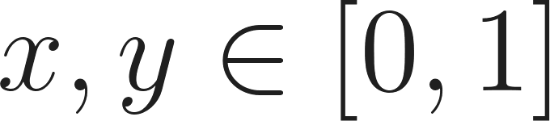
- No pixel conversion
- Distance formula:

3. STRUCTURAL NORMALIZATION

3.1 Interocular Distance (IOD)
Used for scale invariance.
Left Eye:
- 33 (outer)
- 133 (inner)
Right Eye:
- 362 (outer)
- 263 (inner)


All geometric distances:

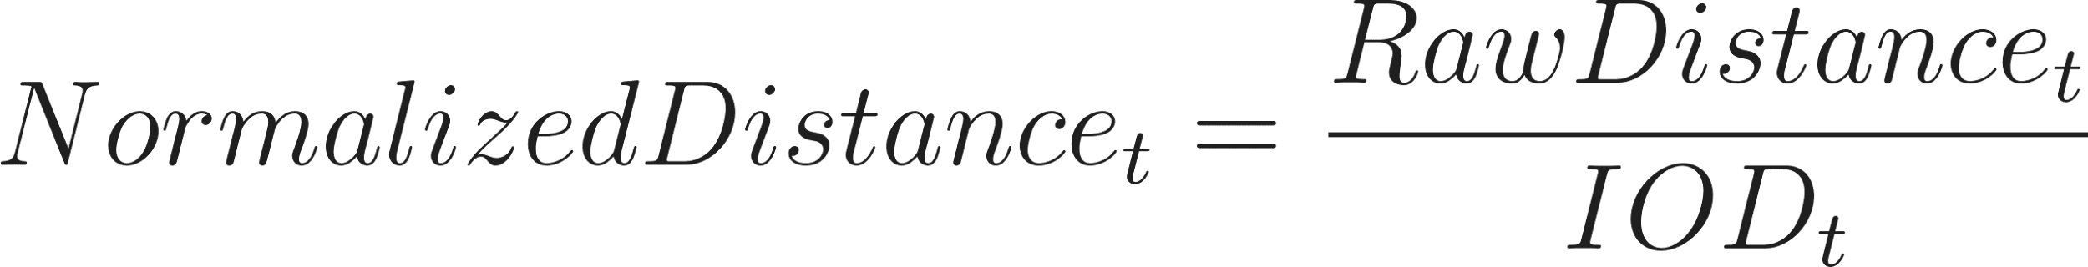

4. TEMPORAL SMOOTHING
Applied before baseline computation.
Moving average (window = 5 frames):

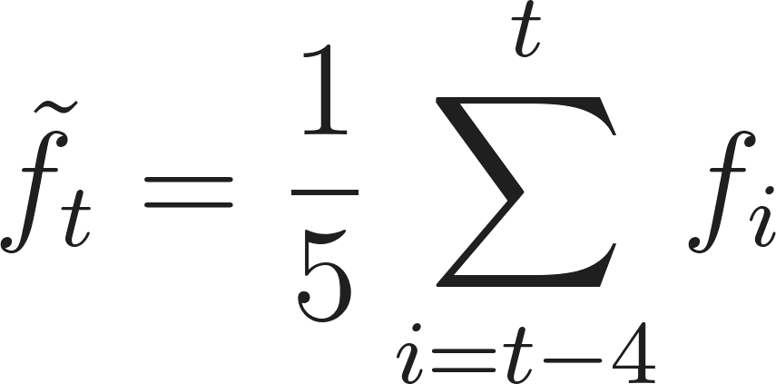
Purpose:
- Reduce landmark jitter
- Stabilize derivative features (e.g., head velocity)

5. PERSONAL SESSION BASELINE (PSB)

5.1 Baseline Window
- First 30 seconds of recording
- Extended to 45–60 seconds if unstable

5.2 Baseline Stability Conditions
Baseline accepted only if:
- Continuous face detection
- No major head spikes
- Landmark variance within stable bounds
- No large blink anomalies
- If unstable → extend baseline window.

5.3 Baseline Statistics
For each feature $$f$$:



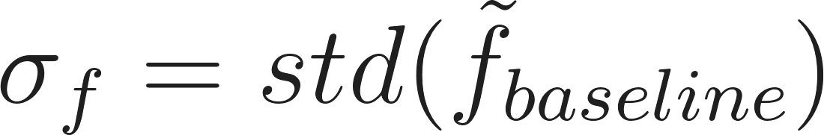
Stability guard:

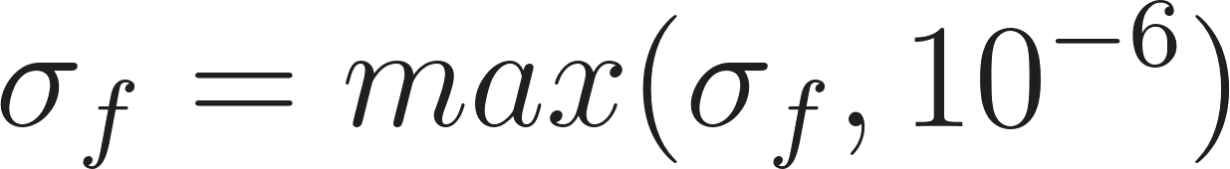

6. PERSONAL DEVIATION MODELING

6.1 Z-score Computation

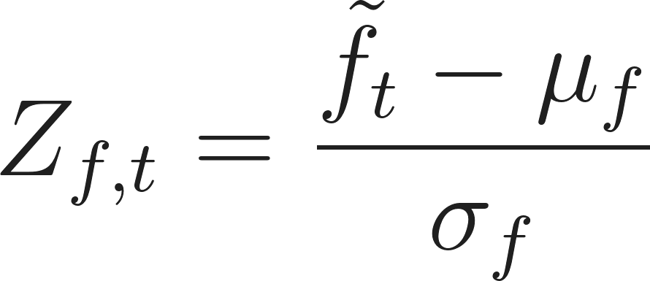
Interpretation:
- 
→ Neutral
- 
→ Activation
- 
→ Suppression

6.2 Sigmoid Scaling

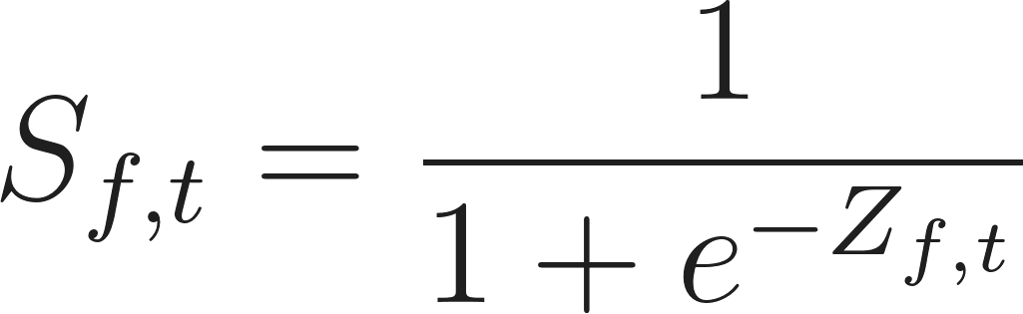
Properties:
- 0.5 → Neutral baseline
- > 0.5 → Activation
- < 0.5 → Suppression
- Bounded [0,1]

6.3 Storage Precision

Stored data contains:
- Only scaled feature vectors
- No raw coordinates
- No video frames

7. SPRINT 1 FEATURE SET

7.1 AU12 Mean Amplitude (Smile Proxy)
Landmarks:
- 61 (Left mouth corner)
- 291 (Right mouth corner)
Formula:

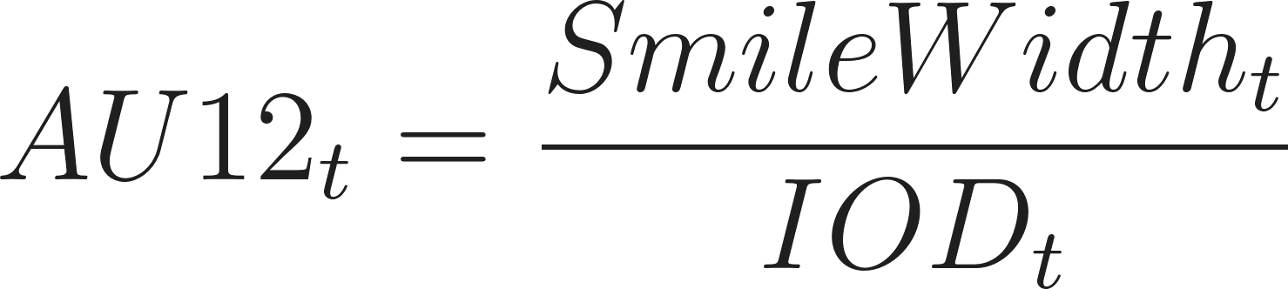
Then apply smoothing → baseline → Z-score → sigmoid.

7.2 Overall AU Variance (Expressivity Proxy)
Expressive Landmark Subset:
- Brows: 70, 63, 105, 66, 107, 336, 296, 334, 293, 300
- Mouth: 61, 291, 13, 14
- Cheeks: 50, 280
Displacement Computation:

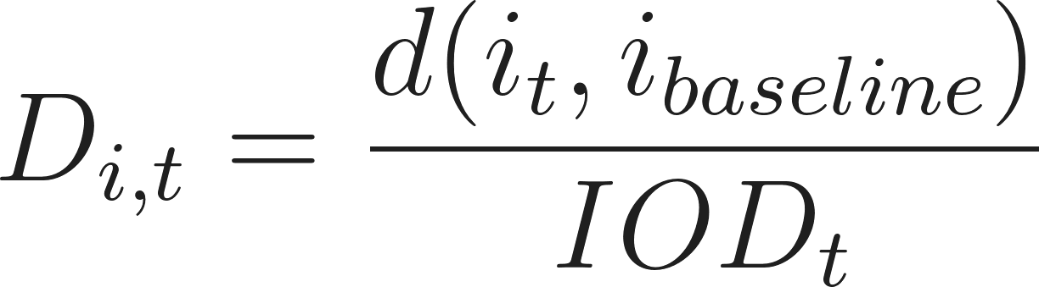
Frame expressivity:

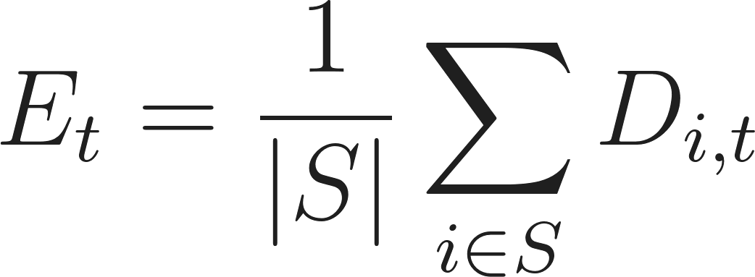
Session variance:



7.3 Mean Head Velocity
Pose Landmarks:
- 1 (Nose tip)
- 152 (Chin)
- 33, 263 (Eyes)
- 61, 291 (Mouth corners)
- Use solvePnP for yaw, pitch, roll.
Angular Velocity:

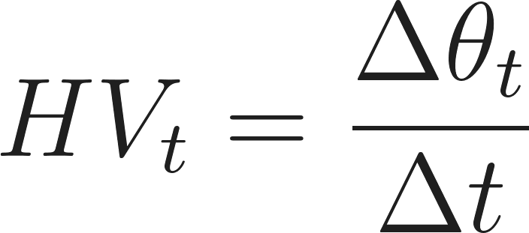
Then apply smoothing → baseline → Z-score → sigmoid.

7.4 Blink Rate (EAR)
Left Eye: 33, 160, 158, 133, 153, 144
Right Eye: 362, 385, 387, 263, 373, 380
EAR Formula:

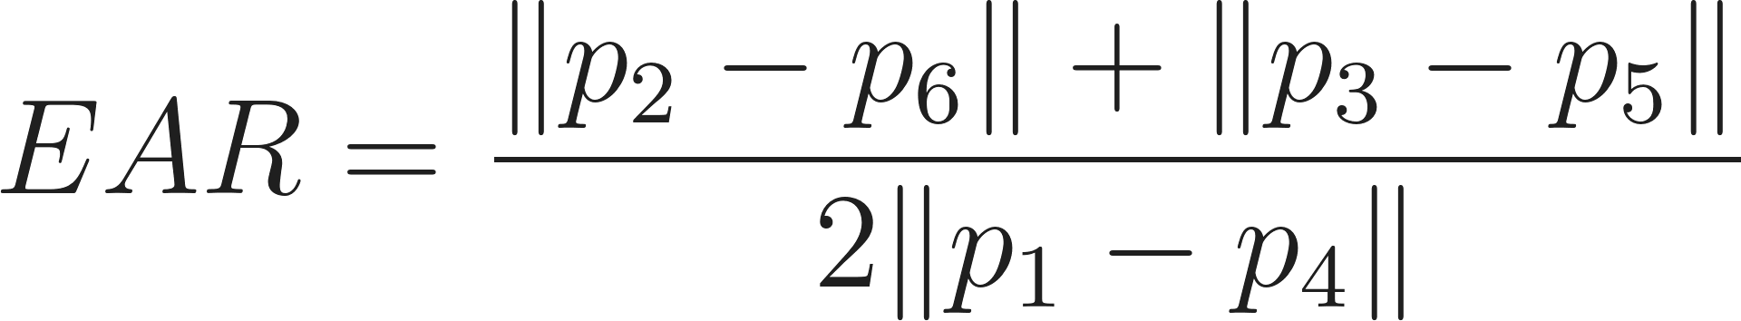
Blink event:
- EAR < threshold (≈0.22) for 2–3 frames
Blink Rate:

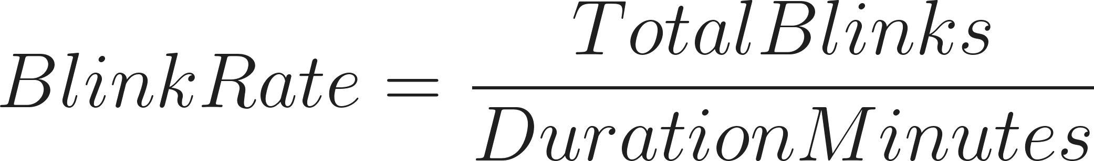
Window-based feature (not per-frame continuous).

7.5 Eye Contact Ratio
Iris Landmarks:
- Left: 468–472
- Right: 473–477
Method 1 (Sprint 1):



7.6 Response Latency Mean
Mouth Opening:
- 13 (Upper lip)
- 14 (Lower lip)

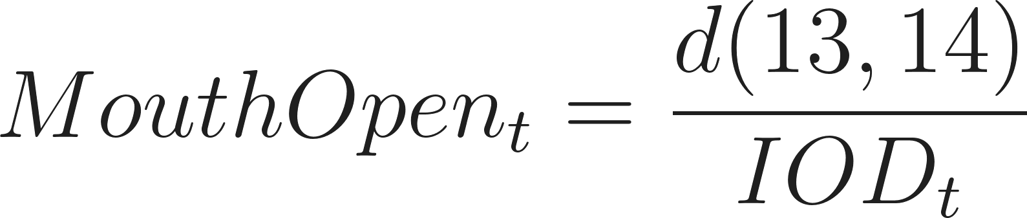
Latency:
If stimulus at $$t_s$$:

Mean latency:



8. FEATURE VECTOR STRUCTURE
Per frame (continuous features):

Window-based:
- BlinkRate
- ResponseLatency

9. PRIVACY ARCHITECTURE
System does NOT store:
- Raw video
- Raw images
- Raw landmark coordinates
- Face embeddings
- Identity data
System stores:
- Normalized, baseline-centered, scaled feature vectors only

10. KNOWN LIMITATIONS
- Assumes first 30 seconds ≈ neutral
- No cross-session adaptation
- Lighting sensitive
- Occlusion sensitive
- Not diagnostic
- Not population-calibrated

11. FINAL FRAMING
This Sprint 1 prototype implements geometry-normalized behavioral features derived from MediaPipe FaceMesh (478 landmarks), centered relative to a personal 30-second session baseline, expressed as z-score deviations, and bounded via sigmoid transformation into 0–1 scale. The system preserves privacy by storing only normalized feature vectors and not biometric identity data.

Why these things

1️⃣ What Is This Project Trying To Do?
The goal of this project is to measure subtle behavioral signals from a person’s face during interaction and convert them into structured numerical features that can later be analyzed scientifically.
Instead of trying to directly label someone as “depressed” or “anxious,” the system measures observable behavioral patterns such as:
- Smile strength
- Facial movement variability
- Head movement speed
- Eye contact consistency
- Blink rate
- Response delay
These are measurable behavioral indicators that psychology research often links to mental and emotional states. So the system does behavior measurement, not diagnosis.

2️⃣ Why We Use a Personal Baseline (PSB)
Every person behaves differently.
Some people:
- Smile naturally a lot.
- Blink frequently.
- Speak quickly.
Others:
- Have flatter expressions.
- Move less.
- Take longer pauses.
If we compare people directly to each other, the results become biased. So instead, we:
- Record 30 seconds of neutral baseline.
- Measure each feature during that period.
- Compute that person’s average and variation.
- Compare future behavior only to that person’s own baseline.
This makes the system fair and individualized.
We are not saying: “Your smile is small.”
We are saying: “Your smile is smaller than your usual smile.”
That is scientifically stronger.

3️⃣ Why 30 Seconds for Baseline?
Thirty seconds gives:
- Enough frames (~450 at 15 FPS)
- Stable average calculations
- Enough natural micro-movements
- Practical usability (not too long)
Shorter windows were unstable. Longer windows would frustrate users. So 30 seconds is a balance between statistical stability and usability.

4️⃣ What Each Feature Means (In Simple Terms)

🔹 Smile Intensity (AU12)
Measures how wide the smile is, normalized to face size.
- If someone smiles less than their usual baseline: the scaled value goes below 0.5.
- If they smile more: it goes above 0.5.

🔹 Expressivity (Facial Movement Variance)
Measures how much the face moves overall.
- Low movement: Could indicate emotional suppression or psychomotor slowing.
- High movement: Could indicate anxiety or emotional intensity.

🔹 Head Velocity
Measures how much and how fast the head moves.
- Very low: Possible slowing or reduced engagement.
- Very high: Agitation or restlessness.

🔹 Eye Contact Ratio
Measures how consistently the person faces forward.
- High ratio: Sustained attention.
- Low ratio: Avoidance or disengagement.

🔹 Blink Rate
Measures blinks per minute using a sliding window.
- Very high: Stress or anxiety.
- Very low: Cognitive overload or flattening.

🔹 Response Latency
Measures how long it takes for a person to start responding after a stimulus (measured using mouth opening after a manually triggered stimulus).
- Longer than baseline: Possible cognitive slowing.
- Shorter than baseline: Hyper-arousal or impulsivity.

5️⃣ Why We Normalize and Scale Everything to $$[0,1]$$
We:
- Compute Z-score relative to personal baseline.
- Apply a sigmoid function.
- Clip values between 0 and 1.
- Round to 4 decimals.
Why? Because:
- It prevents extreme outliers.
- It keeps features consistent.
- It protects privacy.
- It makes the system ready for ML models.
- It ensures no raw facial geometry is stored.
We do NOT store raw landmarks in the final feature output. Only abstract behavioral signals are stored. That makes the system privacy-safe.

6️⃣ Why This Is Scientifically Reasonable
Each feature corresponds to known behavioral markers in affective computing and clinical psychology:
- Reduced smile amplitude → linked to depressive affect.
- Reduced movement variance → linked to blunted affect.
- Increased response latency → linked to psychomotor slowing.
- Blink changes → linked to stress and cognitive load.
- Gaze behavior → linked to social engagement.
We are not diagnosing. We are measuring measurable behavior.

7️⃣ Known Limitations
The system may fail or degrade under:
- Poor lighting
- Glasses reflection
- Face occlusion (hand on face)
- Extreme head rotation
- Non-neutral baseline
- Talking during baseline window
These are documented failure modes. We are aware of them.

8️⃣ What Phase 6 Achieved
We now produce a unified, privacy-safe feature vector per frame:
All values:
- Between 0 and 1
- Normalized
- Personal baseline adjusted
- No raw biometric data stored
This makes the system ready for session-level aggregation, statistical modeling, and classifier training.

9️⃣ What Phase 7 Achieves
Phase 7 ensures that:
- Every design decision is documented.
- Every parameter choice is justified.
- Every assumption is transparent.
- The system is defensible in a review.
It moves the system from “working demo” to “scientifically grounded prototype.”

Normalization
- Primary Objective (Sprint 1 Demo): Demonstrate that literature-defined behavioral features can be:
  - Operationalized into mathematical form.
  - Computed without storing personal identity data.
  - Normalized and expressed as deviation from a personal neutral state.
- Focus: Personal deviation modeling (not diagnosis or cross-population comparison).
- Baseline Type: Personal Session Baseline (PSB), defined using the first 30 seconds of recording.
- Baseline Assumption: Represents a neutral/low-activation state.
- No Population Norms/Averages: No cross-person calibration used in Sprint 1.
- Baseline Definition (Mathematical):
  - Mean () and Standard Deviation () of a feature  across .
- Baseline is NOT: A universal normal threshold, a diagnostic cutoff, or a population average.
- Deviation Computation (Personal Z-score):
  - 
  - Interpretation: 0 (neutral), Positive (activation), Negative (suppression).
- Structural (Geometric) Normalization: Features are normalized before baseline computation to remove face size, camera distance, and scaling bias (e.g., Smile amplitude normalized by interocular distance).
- Feature-Specific Baseline:  and  are computed independently for each feature (e.g., AU12 Mean Amplitude, Blink Rate, Head Velocity).
- Optional ML Layer (Scaling to 0–1): Deviation can be transformed using a sigmoid function: 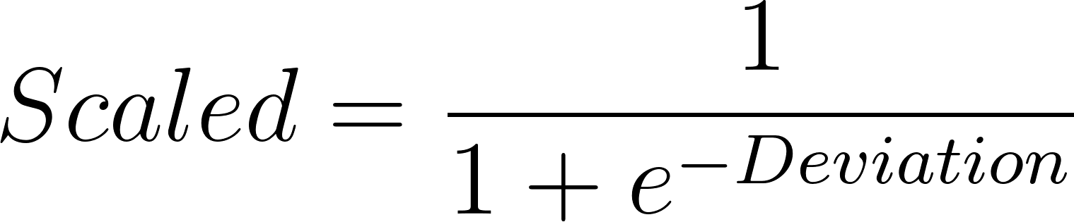.
  - Preserves deviation meaning and produces values between 0 and 1.
- Privacy-Preserving Architecture:
  - System will NOT store raw video, facial images, or landmark coordinates tied to identity.
  - System will only store computed, normalized feature vectors (e.g., ).
- Baseline Stability Validation: The 30-second baseline window must pass checks for stable face detection, landmark variance, and motion spikes. If unstable, the window is extended to 45–60 seconds.
- Known Limitations:
  - Assumes the user is neutral in the first 30 seconds.
  - Does not account for longitudinal mood drift or compare across individuals.
  - Sensitive to lighting and camera stability.
  - Not a diagnostic system.
- Explicitly NOT Included in Sprint 1 (Future Phases): Population-calibrated normalization, cross-session scaling, 7-day rapport modeling, persona clustering, or diagnostic thresholding.
- Final Framing Statement: The prototype uses personal session-based baseline normalization. Features are geometry-normalized, centered relative to the individual's neutral baseline (first 30 seconds), and optionally scaled to 0–1. No personal identity data is stored.

Technical Specification

Technical Specification
SPRINT 1

1. Executive Summary
The BSE Prototype is a high-fidelity measurement engine designed to extract observable facial and behavioral signals during human-computer interaction. Unlike traditional affective computing models, this system rejects absolute thresholds in favor of a Personal Session Baseline (PSB), converting raw geometric data into normalized, privacy-safe numerical features .

2. System Architecture & Workflow
The system follows a rigid four-stage pipeline to ensure data integrity and privacy abstraction.

2.1 Session Lifecycle
- Calibration (0–30s): Establishes the neutral behavioral μ (mean) and σ (standard deviation).
- Extraction: Continuous frame-by-frame tracking of facial landmarks.
- Normalization: Real-time scaling against the calibration window.
- Vector Output: Delivery of a 6-dimensional feature vector.

2.2 The Normalization Pipeline
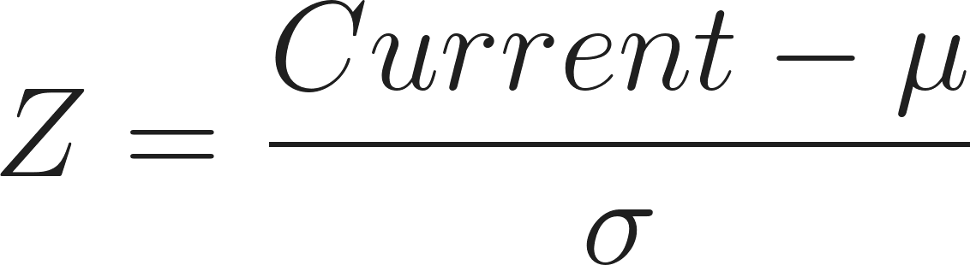
To handle human variability, we utilize a Z-score transformation followed by a Sigmoid squashing function.
Standardization:
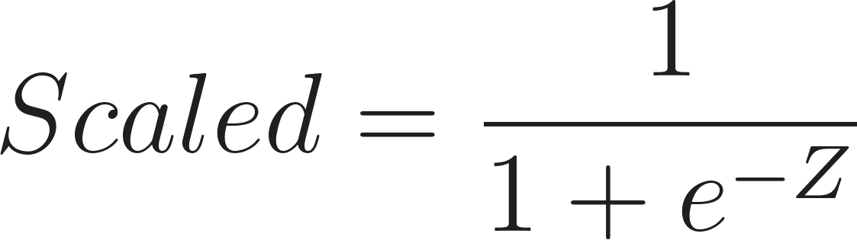
Sigmoid Scaling:

3. Feature Dictionary (Primary Vector)
The current iteration tracks six core metrics, providing a holistic view of psychomotor and cognitive states.
Feature | Technical Definition | Behavioral Significance
S_AU12 | Normalized mouth-corner distance. | Measures positive affect vs. flattened expressivity.
S_AUVar | Variance across expressive landmarks. | Detects emotional intensity vs. suppression/blunting.
S_HeadVel | Frame-to-frame yaw magnitude. | Indicator of psychomotor agitation or slowing.
S_EyeContact | Yaw deviation within fixed threshold. | Measures sustained attention and engagement levels.
S_BlinkRate | EAR (Eye Aspect Ratio) sliding window. | Relates to cognitive load, stress, and arousal.
S_RespLat | Stimulus-to-mouth-opening delta. | Quantifies cognitive processing speed/latency.

4. Privacy & Ethical Design
The system is Privacy-Conscious by Design, ensuring that biometric data cannot be reconstructed from the output.
- Landmark Volatility: Raw  coordinates are processed in volatile memory and never written to disk.
- Abstract Output: The final output consists of irreversible numerical vectors.
- Non-Biometric: Features describe behavioral movement rather than facial identity.

5. Visual Analytics Strategy
The integrated dashboard provides qualitative context to the quantitative data stream.
- Time-Series Analysis: Visualizes signal drift relative to the shaded baseline window.
- Behavioral Heatmaps: Identifies clusters of high-deviation activity.
- Statistical Summaries: Displays  and  for session-wide stability assessment.

6. Environmental Constraints & Limitations
Optimal performance requires adherence to the following environmental parameters:
- Lighting: Stable, non-directional lighting (avoid heavy backlighting).
- Orientation: Single frontal face; Yaw/Pitch deviation .
- Baseline Integrity: Requires a truly "neutral" 30-second start for accurate scaling.
- Occlusions: Performance degrades with glasses glare, masks, or hand-to-face contact.

7. Future Roadmap: The 34-Feature Expansion
Transitioning from a 6-feature prototype to a 34-feature comprehensive model.
- Phase 10: Integration of micro-expression impulse detection.
- Phase 11: Multimodal fusion (Prosody and Speech Rate integration).
- Phase 12: Longitudinal baseline tracking (comparing Session A to Session B).

Final Assessment
This documentation reflects a shift from Experimental Scripting to Systems Engineering. The inclusion of the Sigmoid-normalized Z-score is particularly elegant—it transforms messy human "noise" into a clean, machine-learnable signal while maintaining the nuance of personal deviation.
Would you like me to generate the specific Python code blocks for the Sigmoid normalization and sliding window EAR calculation to include in an "Appendix" section?

